Standard Software Systems

David Graves
Colorado State University Global
CSC505
Dr. Steven Evans
January 15, 2025

Standard Software Systems
There are many different types of software that one can use to develop and deploy programs and applications to accomplish a myriad of different tasks. Python is a language that is widely used in the software development community today. Since its creation in the 1980’s it has been looked at as an excellent source for general purpose software development that emphasizes code readability. To that end it is used today in many cases because it is, “beginner-friendly, while its powerful libraries and frameworks makes it perfect for developers.” (GeeksForGeeks.org, 2025). Regardless of the programming language a developer chooses to use he/she should be mindful of the challenges that they may face. I’ll use the remainder of this paper to share a simple Python program and attempt to answer several questions around the overall challenges present during the development of computer-based software systems.
Python Program
As mentioned, Python is a common coding language that can be used to write simple programs to complex ones. The example below is a common one often used early on in teaching Python that I’ve made one small change by adding a name after the greeting. It’s a simple program that uses the ‘print’ function to display an output that is defined within parentheses and quotes as shown below in Image 1.
Image 1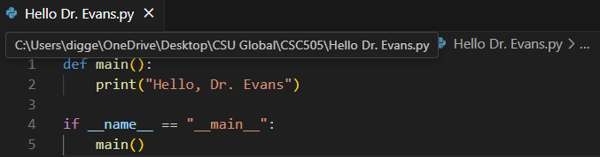
The output from the terminal for this .py program is shown in highlighted text below in Image 2.
Image 2
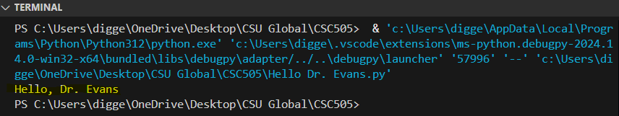
As demonstrated above, one of the key attributes of Python is its readability and its lack of complexity for a simple task. Even though the above is simple, there is an easier way to do this by simply typing > print (‘Hello, Dr. Evans’). This will also produce the same result, as seen in Image 3. This shows another benefit and inherent challenge that there isn’t only one way to do something, which can lead to confusion. Having a good understanding of the language and the challenges in using it can go a long way in helping developers create good clean code.
Image 3
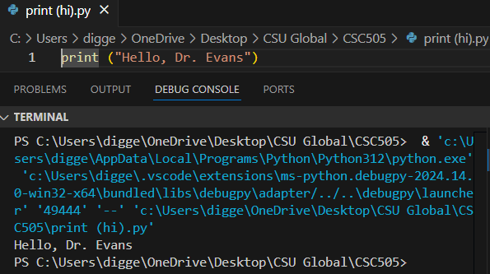
Questions to Ask
Having seen some of the key attributes in using Python should lead one to ask additional questions to better understand the challenges for developers in creating software programs. Why does it take so long to get software finished? There are many reasons and roadblocks that could extend the delivery date for software. In one regard, it depends on the type of software and complexity that it contains at its most basic level. An additional challenge that projects often encounter is changing, missing or unclear requirements. Thayer Tate shares in his article (2025) that, “If there are enough unclear requirements, then you will start to see the project slip”. Why are development costs so high? One answer to this question stems from the previous answer; delays in production. These can be costly when rework is needed to ‘fix’ requirements for a customer due to misunderstanding of the need. Sometimes additional cost can be incurred when contracts aren’t fulfilled on time by incurring fines, or overtime payments to additional resources paid to ensure timelines are met. Both can be troublesome and speak of the overwhelming need to have clear requirements that align closely with the project development calendar. Why can’t we find all errors before we give the software to our customers? One of the challenges while in development that can make it hard to find errors is understanding and replicating the end user environment where the software will be used. Browser configurations, Operating Systems and other company specific proxies and policies can cause issues with software. One good example is within an end user team you may have two or more different users with different versions of software that may be required to integrate with the solution. Why do we spend so much time and effort maintaining existing programs? An additional challenge we see that adds time and expense to maintaining existing programs according to Pressman & Maxim (n.d) is that “Every software failure indicates an error in design…therefore the maintenance tasks that accommodate requests for change involve considerably more complexity than hardware maintenance.” They argue that fixing hardware differs in that it typically isn’t like replacing a like-for-like widget whereas maintaining software can have a knock-on effect with change affecting change. Why do we continue to have difficulty in measuring progress, as software is being developed and maintained? Measuring how successful or not a process can be tricky with software. Since software doesn’t produce physical results independently, like creating bolts without the help of hardware, it can be difficult to understand how successful a piece of software is. Another challenge is that product owners simply see the output and don’t understand the underlying software required to produce expected results. The lack of knowledge of what it takes to maintain software also contributes to a general lack of understanding regarding measuring success which can negatively affect software fixes. It’s much easier finding funding to produce a new software tool but is often difficult to have that same business agree to ‘run’ budget to help fix software down the road when it deteriorates. This turns into somewhat of a circular argument, and the lack of meaningful measurement makes this case doubly hard to prove, therefore it’s critical that clear measurements for success specifically targeting software should be part of project exit criteria.

References
GeeksForGeeks (2025, January 9) Geeksforgeeks.org. Python Tutorial.
https://www.geeksforgeeks.org/python-programming-language-tutorial/

Pressman, R. S., & Maxim, B. R. (n.d.). Software Engineering: A Practitioner’s Approach. Retrieved from:
https://platform.virdocs.com/read/1490446/39/#/4/4

Tate, Thayer (2025). Soltech.net. 6 Common Reasons Software Projects Take Longer Than Expected.
https://soltech.net/reasons-software-projects-take-longer/

